**Steps To Run Attendance System Project:**

1. **Copy the folder containing all project files in your system.**
2. **Launch NetBeans IDE in your system.**
3. **Click “File” Option in menu tab & select “Open Project”.**

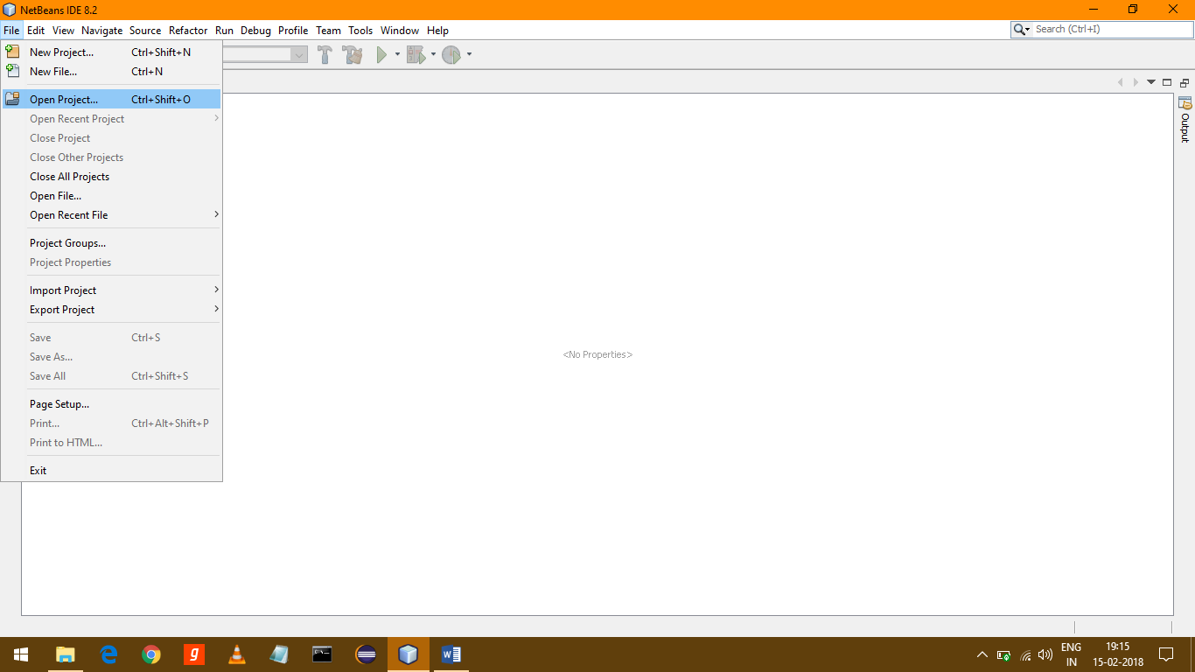

1. **Browse The Folder containing all project files & click Open.**
2. **Open “Projects Tab” by clicking Ctrl+1.**
3. **Right Click on the FaceDetection Project & select Properties.**

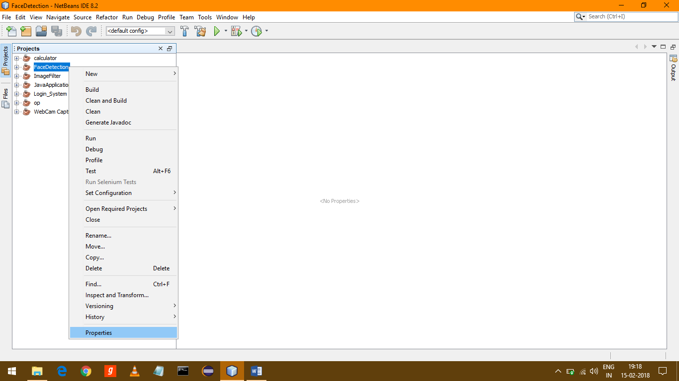

1. **Go to “Run” Category & set path of opencv 330.dll file present in Project Folder in VM Option as shown In Image below. The opencv330.dll file is present in Project Folder copied in First Step :**

